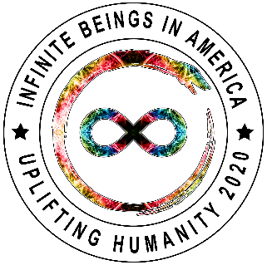
Infinite Beings in America
Certificate of Membership

This certificate bears witness to the bond between the member and Infinite Beings in America and their status as a private, indigenous being with Divine Rights protected by Infinity Scrolls for Infinite Beings in America. (See Infinity Scrolls.8.G.)
Title:
Earth Day: | Date Joined:
Trust Name: | Trust Number:
Earthly Mother: | Earthly Father:
Member Number: | Trustee:
As proclaimed by
Trustee Autograph
Witnessed by
Ajaya Divine, Prime Minster

